The Schools of Sanctuary Award :
Guidance for Completing an Application

Introduction
Schools of Sanctuary is an initiative to celebrate the good practice of schools who foster a culture of welcome and belonging for all, especially asylum seeking and refugee families.
Developed and overseen by City of Sanctuary UK, we are a small refugee sector charity that works to build a movement of welcome in the UK, standing in solidarity with people seeking sanctuary*. We want to see a UK where people seeking sanctuary feel safe and a sense of belonging; are able to thrive and succeed; and where their voices are centered and heard.
The Schools of Sanctuary programme aims to achieve this by:
- working with schools to raise awareness of the experiences of people seeking sanctuary and challenge misconceptions with school pupils, staff, governors, parent/carers and wider communities to build empathy;
- helping schools to build up staff expertise in supporting new arrivals and adopt effective practice and provision to ensure children seeking sanctuary feel safe, a sense of belonging and are able to thrive in school;
- and encouraging schools to connect and collaborate with local charities, organisations and institutions, and community groups to grow and strengthen our shared movement of welcome and solidarity with people seeking safety.
In areas where we have a local delivery partner, or what we call a ‘Local Lead’ schools can also engage with an exciting and rigorous award process to help them go the extra mile and be recognized for doing so. This award process will help schools to think about and shape their efforts to build sanctuary in school and beyond and seeks to bring about a positive impact for staff, students and wider community. See our Local Lead Network here: https://schools.cityofsanctuary.org/the-schools-of-sanctuary-network/local-lead-network.
City of Sanctuary recognises that schools vary in their contexts, so there is no expectation that every School of Sanctuary will follow the exact same path to embedding the ethos of welcome to all and achieving an award. This document outlines the key principles, processes and minimum criteria required for the award, but we encourage schools to build on these in a way that best reflects their unique situation. We so expect every institution to adopt a whole school approach, and we want to see that this journey has been reflective, collaborative and intentional – working to improve practice and provision and foster a culture of belonging and solidarity for those seeking sanctuary.
This guidance is designed to be read alongside the content and resources available on the website, including the audit or self-assessment tool which helps schools to review how existing practice and activities meet the minimum criteria and identify areas for development.
See https://schools.cityofsanctuary.org/resources for the latest resources.

The Application Process
To become a School of Sanctuary, City of Sanctuary UK expects schools to follow the Learn, Embed and Share processes and meet eight minimum criteria. An overview of the necessary steps includes:
Step 1: First, schools must sign an Organisation Pledge which affirms their commitment to the City of Sanctuary vision of welcome for all in the UK: this is also one of the eight minimum criteria to become a Schools of Sanctuary. You can find more information here: Sign an Organisation Pledge.
In signing the pledge you formally join our networks : this is a great opportunity to proudly share your commitment with your community by sharing your pledge in your school newsletter, on your website and on social media.
Step 2: After signing the pledge, you will be connected with your Local Lead who will be your main point of contact and who will oversee your school’s journey and appraisal. Where possible, they will also involve you in local networks and events, help you connect to other schools, and they may be able to offer other forms of support like assemblies, workshops and other local opportunities. Whilst every Local lead is trained and accredited to oversee schools’ award processes, local packages of support and award timelines vary from area to area, so we suggest liaising with your Local Lead to learn more about the local order and discuss timelines for application submission.
Step 3: Make sure to review your school’s current practice and activities, identifying strengths and areas for development. It is not compulsory, but we encourage schools to use our the audit/self-assessment tool to think about all the relevant areas and efforts.
At this point you should also work with students, parent/carers and local partners, especially those with lived experience of seeking safety to hear from them and use their feedback and suggestions to shape your action plan.
We advise schools to take at least a whole school year to work through the process to ensure that this is reflective, collaborative and intentional and bring about a positive impact for students, staff and your community.
Step 4: We advise starting the application early and treating the application as a working document as you move through the process. As you do so, make sure to compile a folder of supporting ‘evidence’. You can learn more about how to complete the application concisely and effectively as you read this guidance note.
Your Local Lead may ask you to submit a draft application in advance of the final submission date to make sure you’re on track and provide helpful feedback and suggestions to ensure it is as strong as possible.
When ready, submit the completed application and evidence portfolio to your Local Lead on the agreed date. This will be reviewed by an appraisal team which include as someone with a background in education and a person with lived experience of seeking safety. Typically this is followed by some initial feedback and a visit to your school to hear from staff, students and parent/carers.
Step 5: After the visit, you will be notified of the award decision – if any final queries remain, you will be given feedback sharing specific suggestions of what you should do to achieve the award and you will be asked to agree a timescale to respond to this feedback. If successful, use this news as an opportunity to reach and engage more members of your community as an opportunity to reach and engage more members of your community in your celebration activities. For instance, get students to contact local press and dignitaries and invite them to be part of your exciting celebratory plans.
This is a phenomenal achievement so make sure to recognise all you have achieved to earn this award. Congratulations!

Becoming a School of Sanctuary
The Core Processes: Learn, Embed & Share
A school can attain an award if they can provide evidence that they have integrated our three core processes:
Learn: growing understanding across the school about the experiences of people seeking sanctuary to challenge misconceptions, build empathy and solidarity, and to help you know best how to support and welcome them.
Embed: taking positive action to embed concepts of welcome, safety and success within the school to ensure everyday culture and practice fosters a sense of belonging and empowerment where everyone can thrive, but particularly students seeking sanctuary. To take steps to ensure this progress remains sustainable, long beyond the initial award.
Share: playing your part in building a culture of welcome more widely – by loudly and proudly sharing their values and efforts and by working collaboratively in the local area and within our movement of welcome.
Co-production with People Seeking Sanctuary
Cutting across all these efforts we expect to see ‘co-production’ with people seeking sanctuary. This is about working meaningfully with new arrivals in your school and community (your students, parent/carers and local refugee organisations) to identify your school’s strengths and areas for development and centering their thoughts, experiences and feedback to make your action plan. After all, we believe we can not build a culture of welcome for people seeking sanctuary without their voices and contributions at the heart of all we do.
If you don’t have children seeking sanctuary or new arrivals in your school or local refugee organisations nearby, we want to see that you have used other resources online or elsewhere to hear their stories and understand the different experiences of people seeking safety and use this to drive your action plan and activities.
The Schools of Sanctuary criteria have been structured to fit into the three overarching processes of Learn, Embed, and Share, which are used for all sanctuary awards. Please provide evidence of meeting each of the criteria in the relevant section of the award application.

The Schools of Sanctuary Minimum Criteria
Learn Criteria
Criterion 1 Staff awareness raising and training: the school raises awareness about the experiences of people seeking safety in the UK amongst all school staff and governors and builds staff expertise to effectively support new arrivals, particularly those seeking safety.
Criterion 2 Student/pupil learning: The school develops learners’ understanding about (forced) migration and the stories and experiences of people seeking sanctuary to foster empathy, including through curricular schemes of work across each age groups/key stage.
Embed Criteria
Criterion 3 Supportive environment and practice: The school reviews, improves and embeds school provision and practice to effectively meet the needs of learners from (forced) migration backgrounds* and foster a culture of belonging for all. *If the school doesn’t have learners from (forced) migration backgrounds yet, we expect the school to demonstrate how it would ensure learners are effectively supported as/when they arrive.
Criterion 4 Community celebration: The school recognises and participates in Refugee Week and other relevant celebratory events to connect with the wider movement of welcome and stand in solidarity with people seeking safety.
Criterion 5 Learner voice and leadership: The school enables learner voice and leadership of the school’s sanctuary activities and seeks to develop learners as ethically informed changemakers.
Share Criteria
Criterion 6 Public commitment: The school proudly shares its commitment to sanctuary in school and with its community by…
- Signing the City of Sanctuary UK supporting organisation pledge
- Sharing its commitment & how it upholds it with the school community (i) in a public space in school, (ii) on the website, (iii) at other possible opportunities.
Criterion 7 Community outreach and partnerships: The school works collaboratively to extend welcome beyond the school gates by participating in activities that stand in solidarity with people seeking sanctuary and/or grow or strengthen our movement of welcome.
Criterion 8 Sanctuary network engagement: The school engages with and supports wider sanctuary networks, including Schools of Sanctuary, to enhance and ensure the sustainability of our efforts.
Filling in the Application
When approaching the application form, we encourage schools to start early and treat it as an ongoing, collaborative process. Many schools find that saving the application form in a shared online drive where multiple staff can access and edit it helps to share responsibility and encourages this to be a wider-staff team initiative rather than the endeavour of one person.
As and when a staff member leads or attends a training session or addresses sanctuary themes in the classroom they can simply add to the application form and upload a relevant form of evidence to the same folder.
Evidence might include lesson plans, schemes of work, powerpoints, meeting agendas, photos, students’ work, etc: all of which could be uploaded to the shared folder, or add hyperlinks to online content such as a training provider’s webpage or a school blog, within the application.
For example, under criterion 1 you might include something like:
Staff Awareness Raising
- All staff and governors attended after school training with Local Lead about the global and local migration context, challenges people seeking sanctuary experience and School of Sanctuary. [see PPT: Training to Staff and Governors]
- The Schools of Sanctuary Lead set-up a staff sanctuary library in the staff room where staff can borrow books on refugee themes, including ‘A Lightless Sky’ by Gulwali Passarlay. [see photo: Sanctuary Library]
Professional Development
- English as an Additional Language (EAL) Lead attended Bell Foundation training for EAL Coordinators in October 22.
- EAL Lead delivered teacher training on EAL pedagogies in the classroom on inset day February 23. [see PPT: EAL pedagogy training]
- Wellbeing and mental health lead attended trauma-informed training with the Anna Freud Centre [see DOC: email registration confirmation] and then cascaded key points to teaching staff in an email notice. [see DOC: email update]. Teacher training planned for the new school year.
- Schools of Sanctuary Lead attended Refugee Education UK Training on Welcoming Newly Arrived Refugee Students.
Some Local Leads might ask for your evidence and application to look a little differently and they might be able to provide some support in completing the application, so we suggest getting in touch with them plenty of time in advance to learn more.

Section Guidance
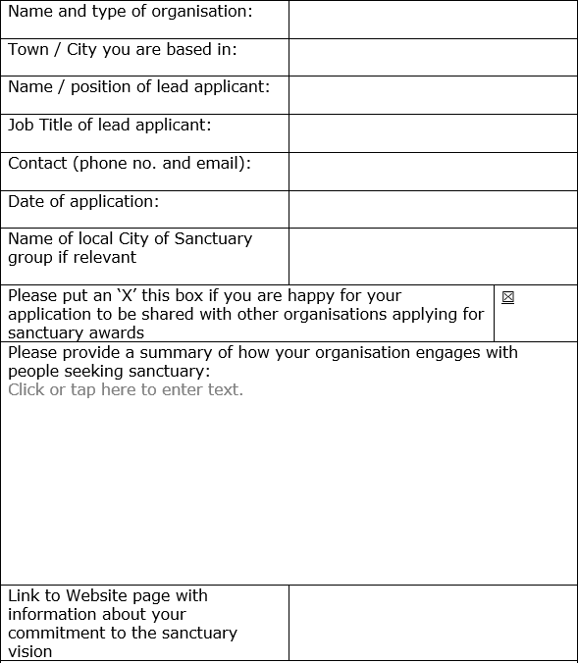
As you complete the application, here are some suggestions to support you in replying to each of the sections.
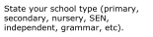

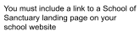

Q: Please provide a summary of how your school engages with sanctuary seekers.
This section helps us to contextualise your school, understand why you are working towards the award and how much prior experience your school has of working with new arrivals. This will help us assess how far your application demonstrates a reflective, collaborative and intentional approach to developing/refining practice and designing activities that can have positive impact.
Briefly summarise your school demographics including whether you have students from sanctuary seeking or migratory backgrounds and, if so, from where. This might include noting student nationalities, numbers of students with English as an Additional Language or classed as New to English or students that have arrived via certain resettlement schemes. Explain if you have a long history of welcoming new arrivals or if this is a newer experience.
If you don’t have students from sanctuary seeking backgrounds in your school community, you can also discuss how your school has sought to build relationships with local people seeking sanctuary and/or formed partnerships with any local support organisations or CoS groups.
It can be helpful to learn about your local context too: has your community welcomed new arrivals recently or are there fewer people from (forced) migration backgrounds?
Q: Using the 3 processes of the sanctuary award, please reflect on how you have achieved these principles attaching evidence to support your answer.
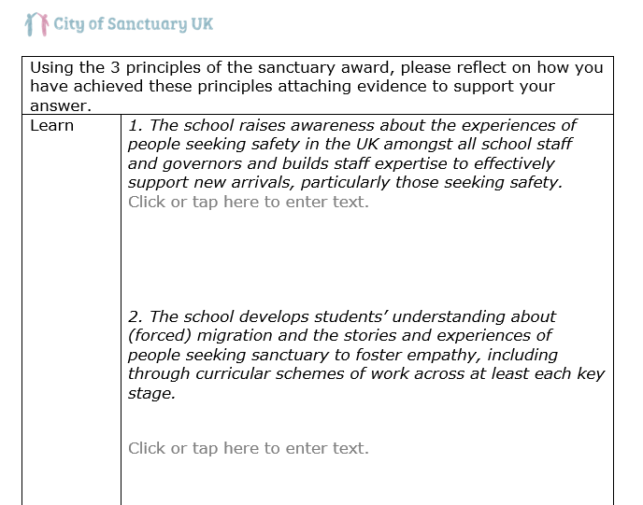
Here we are looking for evidence of your initiatives, projects, policies and progress. Even if something is ongoing, include it as it helps to build a picture of how the school is developing.
We encourage schools to simply briefly bullet-point relevant activities/efforts under each criterion, keeping each point concise and clear.
Please don’t also assume that the appraisal team will have knowledge of your school of the UK education sector, as the appraisal team will include someone with lived experience of seeking sanctuary who might not speak English as a first language and someone without a background in the education sector (so please explain all acronyms and give context where necessary).
See the ‘Filling in the Application’ section for an example of how this can be clearly formatted.
Q: Any other additional supporting evidence
As we typically advise all supporting evidence should be compiled separately, in this section you can simply include anything in addition to the content in the main body of the application. This might include:
- Feedback from others involved
Has feedback from the local community, prospective pupils or the refugee & migrant support sector has been considered? Have there been any changes or actions arising from the activities?
- Feedback from refugee/migrant involvement
It is always useful to include quotes or comments from an asylum seeker, refugee or other migrant groups who have engaged with any aspect of the school’s endeavors.
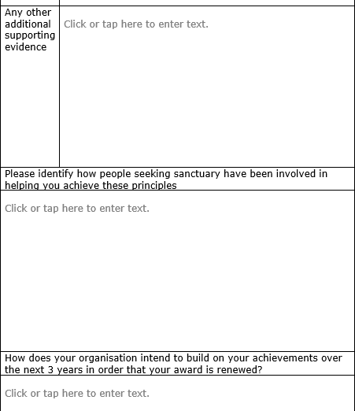
Q: Please identify how people seeking sanctuary have been involved in helping you achieve these principles.
All applications for a Sanctuary Award are expected to involve people seeking sanctuary, refugees and migrants, in the planning, delivery and/or evaluation of activities for each of the principles, where appropriate and possible.
If you have students from sanctuary seeking or migratory backgrounds in the student body how have they, and their parents, been consulted on your practice and activities? Is there a mechanism or space in which they feel empowered to give feedback and advice to the school on what you can improve? How are they supported to lead or develop activities?
If you don’t have students from sanctuary seeking or migratory backgrounds, what engagement have you had with local refugee support organisations to see how you can best support them and the communities they serve?
Q: How does your organisation intend to build on your achievements over the next three years in order that your award is renewed?
We want to acknowledge and celebrate institutions which show a commitment to the principles in the long-term and which have a forward-looking approach; receipt of the sanctuary award is just the beginning! There is no such thing as a ‘perfect’ application and we expect schools to demonstrate an understanding of areas in which they could improve.
Each award is valid for three years and then a school must go through are-accreditation process. Use this section of the application form as an opportunity to share information about your strategic planning and identify 3-5 specific areas for ongoing development. Ideally, we would like to see sanctuary and inclusion built into a school plan.
Questions to ask yourself as you complete this section include: Has your school demonstrated a sustainable commitment to sanctuary in the long-term? Has this effort been embedded in the school plan? How will your school reevaluate and adapt to continue to demonstrate sanctuary, welcome and inclusion? Can you provide evidence that this commitment will continue after the award is granted?

Final note: We ask all schools to keep their applications to no more than 8 pages maximum. We believe this is plenty of space to be able to demonstrate how you meet the minimum criteria and helps to make the appraisal process accessible for all the appraisal team members.

