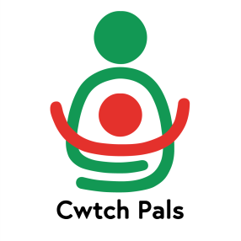
CWTCH PALS CIC

+44 7791 809 810 / +44 1239 820 971
facebook instagram
https://linktr.ee/cwtchpals
cwtchpalswales@gmail.com

CWTCH PALS

SAFEGUARDING POLICY
Cwtch Pals aims to safeguard children, young people and vulnerable adults that we work with by providing safe people, safe places and safe activities providing the necessary expenditure, administration, training, supervision and monitoring of our policy to enable us to support them rebuilding their lives

OUR OBLIGATION TO CHILDREN AND YOUNG PEOPLE
- We will respect children as persons in their own right and give them special protection because of their vulnerability.
- We will accept and stress the main principle of the Children Act 1989 that the child’s welfare is paramount in all circumstances.
- We will act responsibly and with integrity towards children and young people.
- We will not exploit our relationship of trust.
- We will maintain the highest standards of care at all times.

OUR OBIGATION TO ADULTS AT RISK
That all our support workers should work together with adults risk and recognise that all adults have a right to:
- To be treated with respect and dignity
- To have their privacy respected.
- To be able to lead as independent a life as possible.
- To be able to choose how they live their lives
- To the protection of the law.
- To have their rights upheld regardless of ethnic origin, gender, sexuality, impairment or disability, age, religious or cultural background.
- To be heard.

GUIDELINES FOR GOODPRACTICE
- We treat seriously all allegations of abuse, whether physical, sexual, emotional, financial or neglect and act accordingly as set out in this policy.
- All persons working directly with children and young people and/or adults at risk will be suitably trained and complete a Disclosure and Barring Service check as required by the terms of the scheme.
- We will minimise the risks to children, young people and adults at risk by providing a safe, secure environment. Buildings will be checked for safety in accordance with Health and Safety regulations and Guidance.
- If medical need arises we will seek appropriate care.
- When transporting children or adults at risk in any vehicles we will ensure that the vehicle is adequately insured and adheres to current relevant legislation.

We keep informed of changes to the law in the UK, in Wales and the policies and regulations of the relevant local authority in order to comply with current laws and regulations.
We keep a record of the relevant government officer to refer on to should need arise.

If you think a child, young person or vulnerable adult is in immediate danger dial 999.

This Policy was accepted by the Cwtch Pals directors on April 4th 2024 and is reviewed biennually.

The Cwtch Pals safeguarding Officer is Lawrence Mathias ljmathias@yahoo.co.uk

